How To Run The WIP Report
- Log into Presswise with your user name and password. (tpc.mypresswise.com)
- You will need to locate your salesID:
  - How To Find Your User Id#:
    - Click on the admin tab
    - Click on Users (very bottom of the page on the left side of your screen.
    - Click on your sales rep and their salesID number will appear.
- Click on the Report button found on the black ribbon running across the top of the page. It is the third button from the right.
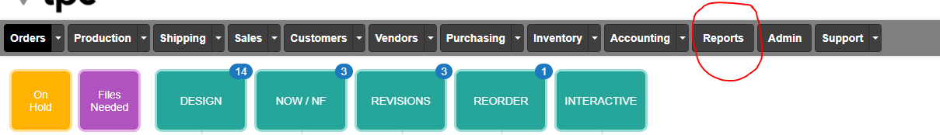
- Select Custom Reports
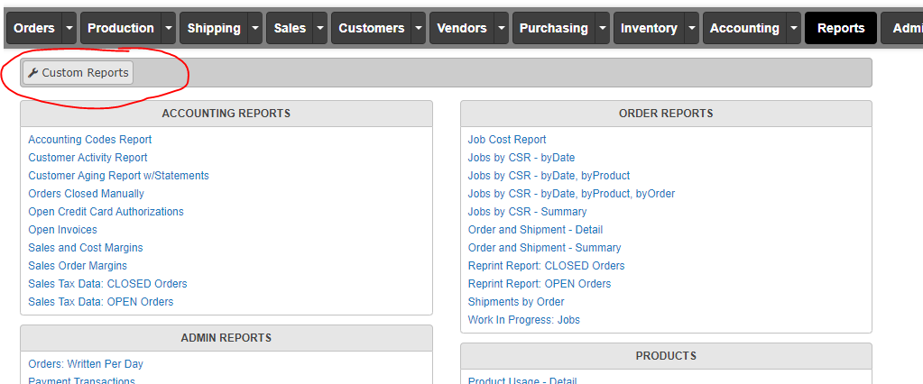
- Select Daily TPC WIP Report
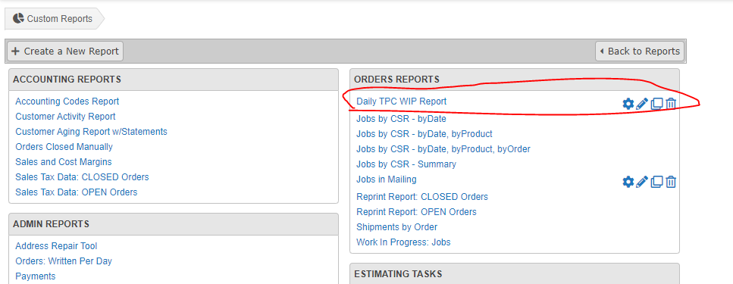
- Put in your sales reps user ID. This will be their ID number, not their name. (For example, Holly is user 15.)
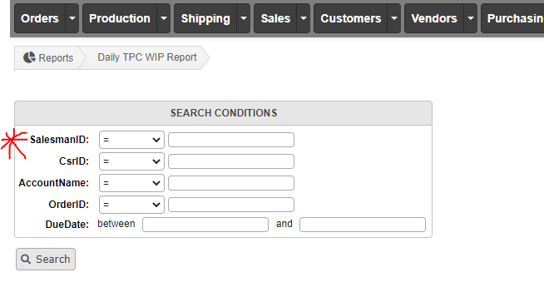
- Click Search
- Click on Export to Excel
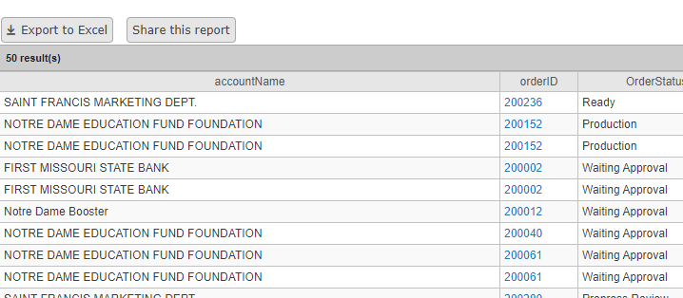

- Your report will look like the following:

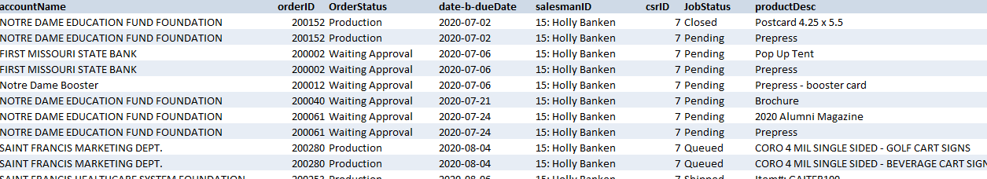

- Print your WIP and submit to Hanna by 9:00am each morning.
Sales Rep and Assistants Guide to Understanding Their Wip

- Rep: Scan the OrderStatus column for any jobs listed in NEW. Circle or highlight any discrepancies.
  - Admin: It is your duty to task the order correctly to ensure it is moving within the system.
- Rep: Scan the OrderStatus column for any jobs listed in AutoNew. Circle or highlight any jobs listed in these statuses.
  - Admin: It is your duty to ensure any jobs in AutoNew have moved on to Production and have not been moved to any Exception ques. A job with an exception will not be listed as such on your WIP.
- Rep: Scan the CSR column and ensure your csr’s name or ID is listed for each job on the WIP. Circle or highlight any discrepancies.
  - Admin: If your name/csrID is not listed on every order on the WIP, any discrepancies must be immediately changed in the order.
Rep: Check the OrderStatus and JobStatus on all order out jobs. They should read Production in the order status and outsourced in the jobstatus. If it says pending or qued in the JobStatus column, your outsourced order has not been placed with the vendor. Circle or highlight any discrepancies.
  - Admin: Discrepancies must be brought to Order Out’s attention for an immediate resolution. Jobs approved before 10:00am and 2:00pm should be placed same business day. If your job was approved at noon on Tuesday it should read Production in the order status and Outsourced in the JobStatus.

Order Status | And what it means…
New | Your ticket has been recently created but has not been tasked to art. Any order sitting in NEW is not moving through the system.
PrePress Review | Your job is currently in art
Ready | Your job has been proofed out to the rep and admin only from the art department
Waiting Approval | Your Job has been proofed to your client by either admin or sales rep
AutoNew | Your job has been approved
Production | Your job has reached Production
Shipped | Your job is completed and has shipped and/or delivered to your customer.
Closed | Your job has completed and has been archived.
JobStatus | And what is means…..
Pending | Your job has been approved and is slotted for plates or high-resing
Qued | Your job has been plated and/or high-res and is ready for ordering or printing.
Outsourced | Your outsourced job has been ordered
Print | Your job is being printed
Cut | Your job is in bindery
Finished | Your job is ready to be prepared for delivery
Boxed | Your job is complete and packaged for delivery
Closed | The production aspect of your job has been completed and has shipped or delivered.

DAILY WIP CHECKLIST
Date:______________
 | ADMIN INITIALS | TASK
 |  | DANGER! Do you have any jobs listed as “NEW” or “HOLD”? This means: Your job is stuck and not moving.
 |  | DANGER! Do you have any jobs in “EXCEPTIONS”? This means: Your job is stuck and not moving.
 |  | Do you have any jobs that have been in prepress review (new art) for more than 48 hours?
 |  | Do you have any jobs that have been in waiting for approval for more than 30 days? This means: The client must be billed for design time if they aren’t moving forward with the job.
 |  | Are all your NOW and NO FLEX jobs on schedule? Are you communicating with customer support for assurance?
 |  | Do all of your NOW and NO FLEX jobs have a 9, 10, 11, 13, 14 or 16 beside them? If not: Your job could slip through the cracks.
 |  | ALERT! Look at all jobs that have a “Ready” status. This means: Your job has not been proofed out to the customer. Once the job has been proofed out it should read “Waiting Approval.”
 |  | Do you have any jobs that have been in revisions for more than 24 hours?
 |  | Do you have any jobs that have been in outsourced/pending for more than 24 hours?
 |  | ALERT! Check the jobs that are in “Production” and say “Pending.” Art plates at 10:00am each morning. No job should be in the “Pending” status for more than 24 hours.
 |  | Do you see any jobs on your WIP that you know have already delivered or are past due? If so, contact customer support immediately for resolutions or closure.
 |  | Are any orders missing from WIP that were submitted before 2pm the previous day?
 |  | Do you have any orders that are not on the list that came in via phone or walk up?
 |  | Are any orders missing from WIP that were submitted after 2pm the previous day?
 |  | Are you missing any vendor proofs?
 |  | STOP!!! COLLECT!!! Or put on HOLD! If your customer is COD and you have not collected ½ down, order must be put on HOLD.
Additional Notes: ______________________________________________________________________________________________________________________________________________________________________________________________________________________________________________________________________________________________________

